PROJECT REPORT
SPECTRUM
Hyperspectral Analysis System
Real-Time Conversion of RGB Camera Feeds into 401-Band Hyperspectral Data (380–780 nm) Using Machine Learning

Project Title: | SPECTRUM – Hyperspectral Analysis System
Team / Group: | SpectraX (Sanket Dale)
Institution: | Sanjivani University
Guide / Mentor: | Arvind Mukundan
Date: | October 2026

1. Abstract
Conventional colour cameras record only three broad channels (red, green and blue) and therefore discard most of the spectral information carried by light. Dedicated hyperspectral cameras recover this information but are costly, bulky and slow to deploy. This report presents SPECTRUM, a desktop Hyperspectral Analysis System that uses machine learning to convert standard RGB camera feeds into 401-band hyperspectral data covering 380 nm to 780 nm in real time.
The transfer model combines polynomial colour expansion with Principal Component Analysis (PCA) to map each RGB pixel to a full spectrum. The application is written in Python with PyQt6, OpenCV and Matplotlib, and accepts images and live feeds from standard webcams, Picamera2 and GStreamer pipelines. Users annotate regions of interest (ROI) with point, rectangle, ellipse and polygon masks and immediately see the resulting spectra together with metrics such as peak wavelength, spectral energy and warm/cool classification. Advanced tools estimate metameric similarity between regions and correlated colour temperature (CCT) in Kelvin. Results can be exported to CSV and multi-sheet Excel workbooks.
The project is organised as an open-source repository containing the application, training data, evaluation scripts, an output folder and installer scripts. SPECTRUM shows that useful spectral analysis can be delivered on low-cost hardware, with applications in agriculture, manufacturing and food quality inspection.
Keywords: hyperspectral imaging, RGB-to-spectrum reconstruction, machine learning, PCA, metamerism, PyQt6, real-time analysis.
Table of Contents
1. Abstract2
2. Introduction4
3. Problem Statement5
4. Objectives6
5. Literature Review / Existing System7
6. Proposed System8
7. System Architecture9
8. Methodology10
9. Dataset / Input Data11
10. Data Preprocessing12
11. Models / Algorithms13
12. Implementation14
13. Hardware / Software Integration15
14. Results and Evaluation16
15. Prototype / Application17
16. Discussion18
17. Limitations18
18. Future Scope19
19. Conclusion19
20. References and GitHub Repository20
List of Figures and Tables
Figure 1: SPECTRUM system architecture9
Figure 2: RGB-to-spectrum transfer model pipeline13
Figure 3: Excel export of ROI spectral data14
Figure 4: Spectra of multiple ROIs in SPECTRUM16
Figure 5: Application interface in ready state17
Figure 6: Application interface during live analysis17
Table 1: Comparison of spectral acquisition approaches7
Table 2: Software stack14
Table 3: Supported camera interfaces15
Table 4: Repository structure20

2. Introduction

2.1 Background
Light reaching a camera is a continuous distribution of energy across wavelengths. Hyperspectral imaging (HSI) measures this distribution at many narrow, contiguous bands for every pixel, producing a spectral signature that characterises the material being observed [1], [2]. Because different materials absorb and reflect wavelengths differently, spectra can reveal properties such as chemical composition, moisture, ripeness or surface coating that remain invisible in an ordinary photograph.

2.2 Domain Overview
HSI is established in remote sensing, medical imaging, agriculture and industrial inspection [2], [10]. However, most systems rely on specialised push-broom or snapshot sensors that are expensive, require careful calibration and are difficult to use outside a laboratory.

2.3 Motivation
Every smartphone, webcam and embedded board already contains an RGB sensor. If a trained model can estimate the full spectrum from RGB values, spectral analysis becomes available to students, farmers, quality engineers and small manufacturers at negligible hardware cost. This motivated the development of SPECTRUM.

2.4 Project Context
SPECTRUM is a Python desktop application that performs real-time RGB-to-hyperspectral conversion over the range 380–780 nm at 1 nm resolution (401 bands), and provides interactive tools to select regions, compare spectra, compute metrics and export data. The complete source code, training data, evaluation scripts and installer are maintained in a GitHub repository.

3. Problem Statement
Standard RGB cameras compress the visible spectrum into three channel values per pixel. This loss of information prevents reliable discrimination of materials whose colours look identical to the camera. A practical, low-cost way to recover spectral information from ordinary camera feeds is therefore needed.

3.1 Key Challenges
- Metamerism: surfaces with different spectra can yield identical RGB values, so colour alone is ambiguous.
- Ill-posed reconstruction: estimating 401 values from 3 measurements has no unique solution and requires learned prior knowledge.
- Real-time constraint: the model must run fast enough for live video on modest hardware.
- Hardware diversity: webcams, Raspberry Pi cameras and streaming pipelines expose different interfaces.
- Usability: non-experts need simple tools to select regions, read results and export data.

3.2 Target Users
Researchers and students in spectroscopy and computer vision, agricultural technologists, manufacturing quality-control engineers and food-quality inspectors.

4. Objectives

4.1 Main Objective
To design and implement an open-source system that converts standard RGB camera input into 401-band hyperspectral data in real time and provides interactive analysis and export tools.

4.2 Specific Technical Objectives
- Develop a machine-learning transfer model (polynomial colour expansion with PCA) that reconstructs spectra from 380 nm to 780 nm at 1 nm steps.
- Support images and live feeds through OpenCV, standard webcams, Picamera2 and GStreamer.
- Provide ROI annotation tools: point, rectangle, ellipse and polygon masks.
- Compute real-time metrics: peak wavelength, spectral energy and warm/cool classification.
- Enable advanced comparison through metameric similarity and CCT in Kelvin.
- Export ROI spectra to CSV and multi-sheet Excel files.
- Deliver a PyQt6 and Matplotlib interface with live graph plotting.
- Make the project reproducible through a modular GitHub repository and an installer.

5. Literature Review / Existing System
Spectral acquisition has been addressed by hardware, optimisation and learning-based approaches. Dedicated hyperspectral cameras provide accurate measurements but at high cost and complexity [2]. Arad and Ben-Shahar proposed recovering hyperspectral signals from single RGB images through sparse dictionary methods [3]. The NTIRE challenges on spectral reconstruction from RGB subsequently stimulated deep-learning approaches with strong accuracy [4].
Table 1: Comparison of spectral acquisition approaches
Approach | Strengths | Limitations
Hyperspectral cameras | Direct, high-fidelity spectra | High cost, bulky, slow acquisition
Sparse dictionary recovery [3] | No special hardware; interpretable | Costly optimisation per image
Deep-learning reconstruction [4] | High reconstruction accuracy | Heavy compute; limited interactive tooling
SPECTRUM (this work) | Lightweight, real-time, full analysis toolkit | Accuracy bounded by training data and camera

5.1 Identified Gap
Existing research focuses mainly on reconstruction accuracy. Few solutions combine real-time inference, multi-camera support, ROI-based analysis, comparison metrics and data export in a single, easily installed application. SPECTRUM addresses this gap.

6. Proposed System
SPECTRUM is a desktop application that reconstructs a 401-band spectrum for every selected pixel or region of an RGB image or live camera stream. A machine-learning transfer model based on polynomial colour expansion and PCA performs the conversion, and an integrated interface presents, compares and exports the results.

6.1 Novelty
The novelty lies in packaging a lightweight RGB-to-spectrum model together with practical analysis tools (ROI masks, spectral metrics, metameric similarity, CCT) and hardware flexibility, turning an ordinary camera into an accessible spectral instrument.

6.2 Key Features
- Real-time RGB-to-hyperspectral conversion (380–780 nm, 401 bands).
- ROI tools: point, rectangle, ellipse and polygon masks with zoom control.
- Live spectral graphs with multi-ROI overlay for comparison.
- Metrics: peak wavelength, spectral energy, warm/cool classification.
- Metameric similarity and colour temperature (CCT) in Kelvin.
- Export to CSV and multi-sheet Excel; works with OpenCV, webcams, Picamera2 and GStreamer.

7. System Architecture
SPECTRUM follows a modular pipeline from image acquisition to analysis and export, as shown in Figure 1.
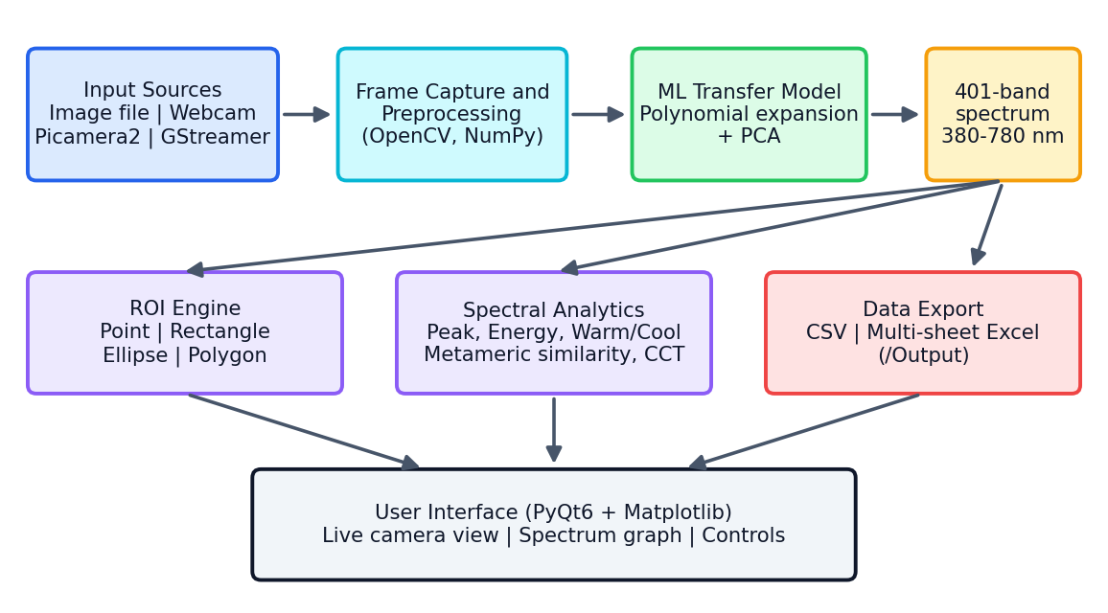
Figure 1: SPECTRUM system architecture
- Input module: loads image files or captures frames from webcams, Picamera2 or GStreamer sources.
- Preprocessing module: prepares frames for the model (colour order and scaling).
- Transfer model: converts RGB values to 401-band spectra.
- ROI and analytics modules: extract region spectra and compute metrics and comparisons.
- Interface and export modules: display graphs and write CSV/Excel files to /Output.

8. Methodology / Workflow
The complete workflow from input to output consists of the following steps:
- Acquire input: the user loads an image or connects a camera and captures a frame.
- Preprocess: the frame is converted to RGB order and normalised for the model.
- Annotate ROI: the user draws point, rectangle, ellipse or polygon masks on the image.
- Extract colour: the RGB values inside each mask are collected.
- Reconstruct spectrum: polynomial expansion and the PCA-based model produce 401 intensity values (380–780 nm).
- Visualise: spectra are plotted in the Matplotlib panel, one curve per ROI, with a legend.
- Analyse: peak wavelength, spectral energy, warm/cool class, metameric similarity and CCT are computed.
- Export: after entering an ID, the user exports ROI data to CSV or Excel; annotations can be cleared or reset.

9. Dataset / Input Data
The ML transfer model is trained and validated on the data stored in the /Data set/ folder of the repository. The data pair RGB colour values with measured or reference spectra over 380–780 nm, which allows the model to learn the mapping from three channels to 401 bands.
Each training sample consists of an RGB input and a 401-value spectral target covering 380–780 nm at 1 nm spacing. The data are split into training and validation subsets, and the validation subset is used by the scripts in the /Evaluation/ folder to check reconstruction accuracy.
At run time the system also accepts live input: still images loaded from disk and frames captured from a camera. These are processed pixel-wise through the trained model.

10. Data Preprocessing
Preparation is applied both to the training data and to run-time frames so that the model always receives consistent input.

10.1 Training Data Preparation
- Align all reference spectra to the common 380–780 nm grid at 1 nm spacing (401 values).
- Normalise RGB values to a fixed numerical range.
- Fit PCA on the spectra to obtain a compact basis, then split the data into training and validation sets.

10.2 Run-Time Frame Preparation
- Convert camera frames from OpenCV’s BGR channel order to RGB.
- Scale pixel values to the model’s expected range.
- Resize frames for display while preserving the aspect ratio; zoom in/out is available in the interface.
- Build pixel masks from the ROI shape (point, rectangle, ellipse, polygon) to select the pixels to analyse.
These steps keep the conversion fast enough for real-time use.

11. Models / Algorithms Used
The transfer model reconstructs spectra from RGB using polynomial colour expansion and PCA (Figure 2).
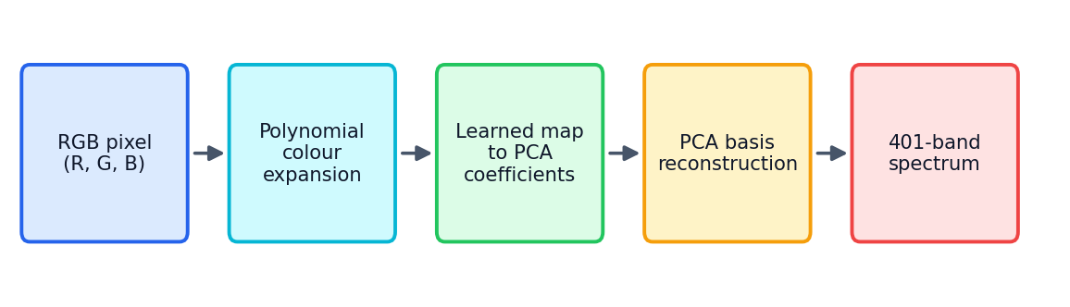
Figure 2: RGB-to-spectrum transfer model pipeline
- Polynomial colour expansion: each RGB triplet is expanded into polynomial terms (e.g. products of R, G and B), capturing non-linear colour–spectrum relationships.
- PCA: natural spectra are highly correlated; PCA represents them with a few coefficients, so the model predicts a few values instead of 401.
- Reconstruction: the full spectrum is rebuilt from the predicted coefficients and the PCA basis.
- Why this approach: it is lightweight, fast, stable and interpretable, which suits real-time CPU inference.
Derived metrics use simple algorithms: peak wavelength is the wavelength of maximum intensity; spectral energy aggregates intensity over the range; warm/cool classification compares the balance of long and short wavelengths; CCT is estimated from the spectrum’s chromaticity [5].

12. Implementation Details
SPECTRUM is implemented in Python. Table 2 lists the main libraries, which are declared in the repository’s Requirement.txt file.
Table 2: Software stack
Library | Role
PyQt6 | Desktop GUI: windows, buttons, ROI toolbar
OpenCV | Image loading, camera capture, frame handling
Matplotlib | Real-time spectrum graph plotting
NumPy | Numerical arrays and model computation
Pandas | Tabular data for CSV and Excel export

The main program is /App/spectrum_app.py. The installer scripts in /installer/ package it as a standalone executable. Exports follow the layout in Figure 3, with ROI ID, ROI type, wavelength and intensity for every band.
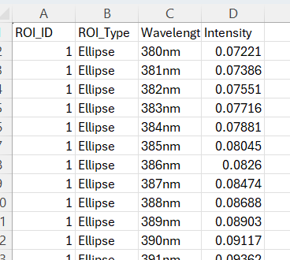

Figure 3: Excel export of ROI spectral data

13. Hardware / Software Integration
SPECTRUM requires no specialised sensor. It reads images from any camera that exposes one of the supported interfaces (Table 3), so the same application and model run on a laptop or on an embedded board.
Table 3: Supported camera interfaces
Interface | Typical hardware | Use case
OpenCV | Built-in and USB webcams | Desktop analysis
Picamera2 | Raspberry Pi camera modules | Low-cost edge deployment
GStreamer | Embedded and network video pipelines | Streaming and custom sources

Connection is made from the interface with the Connect Camera button; Capture Image grabs a frame for analysis and Save Image stores it. Image quality affects the estimated spectra, so stable lighting, fixed exposure and consistent white balance are recommended. Because the system runs entirely on a standard computer, no additional processors or sensors are required.

14. Results and Evaluation
Figure 4 shows spectra generated by SPECTRUM for six ROIs (three points, two rectangles and one ellipse) selected from a single live camera frame.
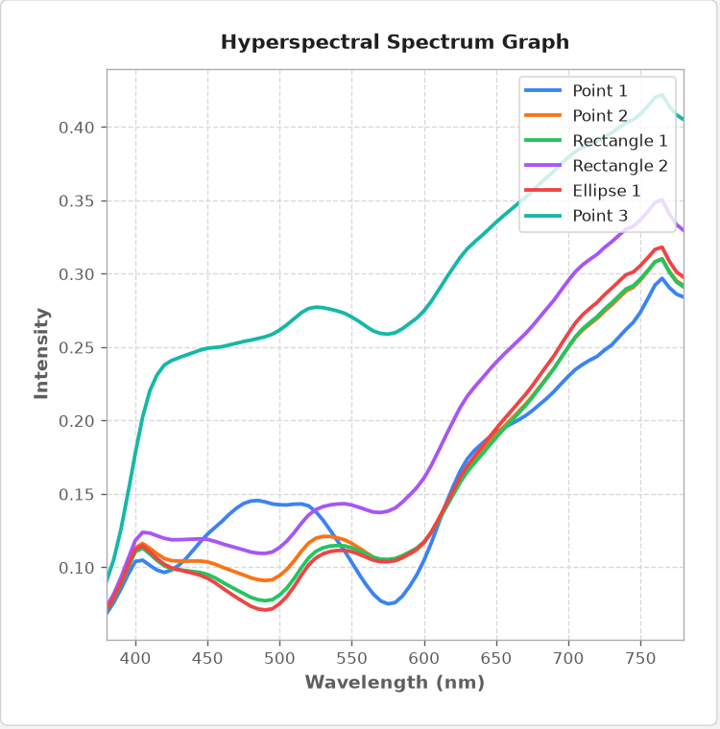
Figure 4: Spectra of multiple ROIs in SPECTRUM
All curves span 380–780 nm and show smooth, continuous profiles. Intensity generally rises beyond about 600 nm. The point on a bright background region (Point 3) has the highest intensity throughout, while Point 1 shows a distinct dip near 550–575 nm. Different regions yield distinguishable curves even though the input is only RGB.

15. Prototype / Application
The interface is built with PyQt6 and Matplotlib. The left panel shows the image or camera feed with the ROI toolbar (Point, Rect, Ellipse, Zoom Out, Zoom In); the right panel plots spectra. The bottom bar contains Load Image, Connect Camera, Capture Image, Save Image, an ID field (required for export), Export Excel, Clear Annotation and Reset.
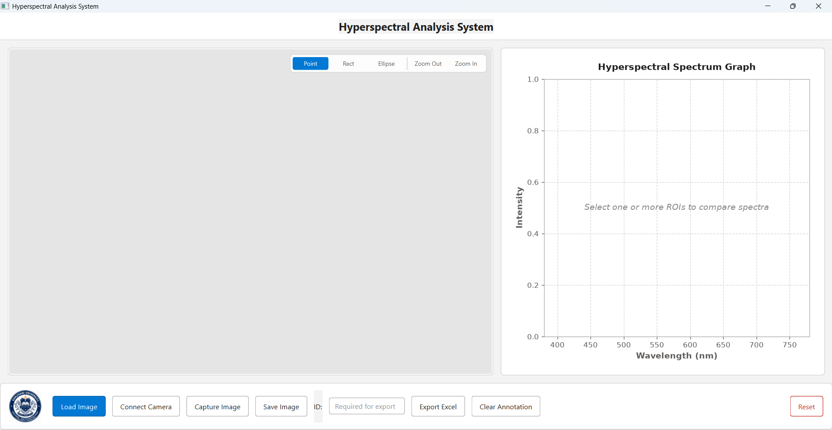
Figure 5: Application interface in ready state
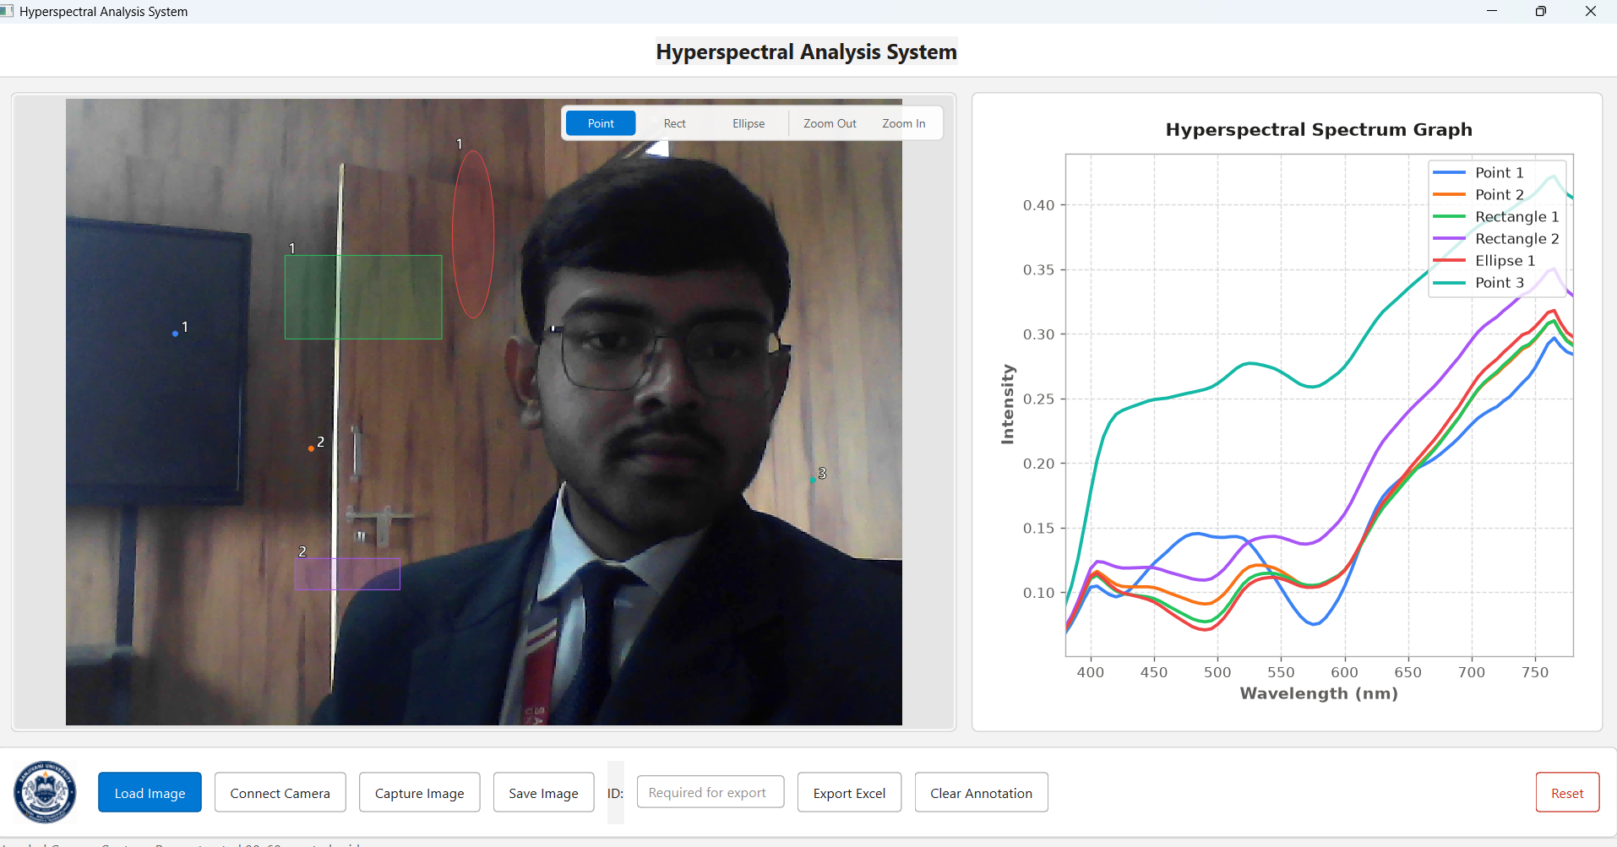
Figure 6: Application interface during live analysis with multiple ROIs

16. Discussion
SPECTRUM demonstrates that spectral information can be estimated from ordinary cameras with a lightweight model. Its main advantages are low cost, real-time operation, hardware flexibility and an integrated workflow from capture to export. The metameric comparison and CCT tools make the benefit of spectral data tangible to non-experts.
Observations from the prototype show that different regions produce distinguishable spectra and that the interface remains responsive during live use.

17. Limitations
- Reconstruction is an estimate; accuracy depends on training-data coverage and may be lower for materials outside it.
- Metameric pairs cannot be separated perfectly because RGB inherently lacks the missing information.
- Results depend on lighting, exposure and white balance of the camera.
- Quantitative validation is limited to the data and scripts in /Evaluation/.

18. Future Scope
- Expand and diversify the training dataset across materials and illumination conditions.
- Evaluate deeper models while keeping real-time performance.
- Add per-camera calibration, illumination correction and further export formats.
- Develop domain modules for crop health, defect detection and ripeness estimation.
- Deploy on embedded devices and extend to video recording and batch processing.

19. Conclusion
SPECTRUM converts standard RGB camera feeds into 401-band hyperspectral data between 380 nm and 780 nm in real time. By combining a polynomial-expansion and PCA transfer model with ROI tools, spectral metrics, comparison features and CSV/Excel export, it makes spectral analysis accessible on low-cost hardware. The open-source, modular repository supports reproducibility and further development, and the system is a practical step towards widespread spectral sensing in agriculture, manufacturing and food quality.

20. References and GitHub Repository
[1] A. F. H. Goetz, G. Vane, J. E. Solomon and B. N. Rock, “Imaging spectrometry for Earth remote sensing,” Science, vol. 228, no. 4704, pp. 1147–1153, 1985.
[2] G. Lu and B. Fei, “Medical hyperspectral imaging: a review,” J. Biomed. Opt., vol. 19, no. 1, 010901, 2014.
[3] B. Arad and O. Ben-Shahar, “Sparse recovery of hyperspectral signal from natural RGB images,” in Proc. ECCV, 2016.
[4] B. Arad et al., “NTIRE 2020 challenge on spectral reconstruction from an RGB image,” in Proc. CVPR Workshops, 2020.
[5] G. Wyszecki and W. S. Stiles, Color Science: Concepts and Methods, Quantitative Data and Formulae, 2nd ed. Wiley, 2000.
[6] I. T. Jolliffe, Principal Component Analysis, 2nd ed. Springer, 2002.
[7] G. Bradski, “The OpenCV Library,” Dr. Dobb’s Journal of Software Tools, 2000.
[8] J. D. Hunter, “Matplotlib: a 2D graphics environment,” Comput. Sci. Eng., vol. 9, no. 3, pp. 90–95, 2007.
[9] C. R. Harris et al., “Array programming with NumPy,” Nature, vol. 585, pp. 357–362, 2020.
[10] Y. Lu et al., “Recent advances of hyperspectral imaging technology and applications in agriculture,” Remote Sens., vol. 12, no. 16, 2659, 2020.
Table 4: Repository structure
Path | Contents
/App/ | Core application (spectrum_app.py) and UI assets
/Data set/ | Training and validation data for the transfer model
/Evaluation/ | Scripts and notebooks validating RGB-to-spectrum accuracy
/Output/ | Exported CSV/Excel data and saved graphs
/installer/ | Scripts and binaries for a standalone executable
Requirement.txt | PyQt6, OpenCV, Matplotlib, Pandas, NumPy
Repository: https://github.com/SMARTLAB-SU/SPECTRUM
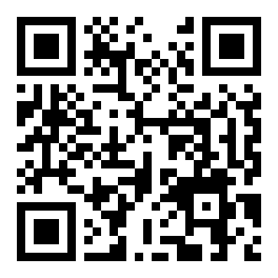
Acknowledgements: The team SpectraX thanks mentor Arvind Mukundan and Sanjivani University for their guidance and support.

